# **Interim Report**

What we achieved…

1. System Requirements Analysis – 10%
2. Workflow – 20%

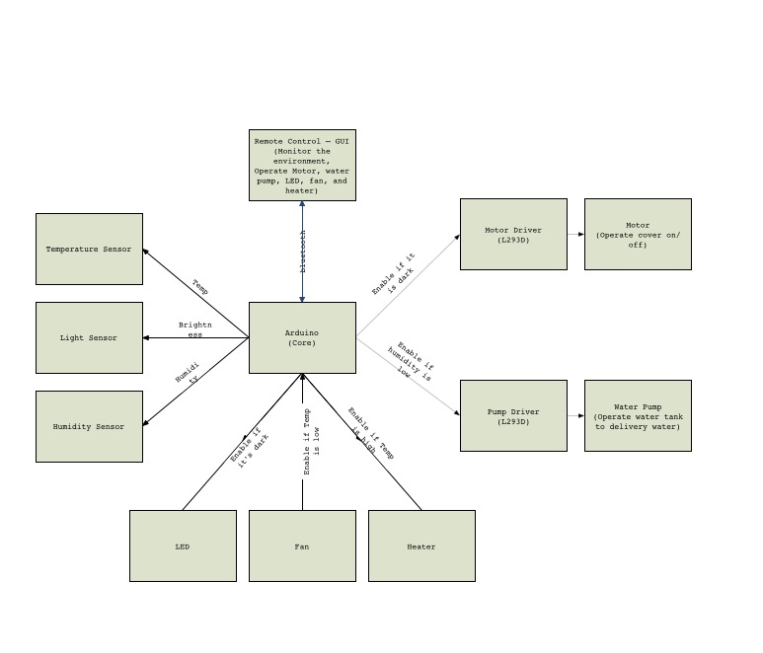

1. Hardware – 30% (25%)
   1. Components Testing – 10%

|  |  |
| --- | --- |
| Soil Moisture Sensor | ✔ |
| Temperature Sensor | ✔ |
| Light Sensor | ✔ |
| Water Pump | ✔ |
| Motor | ✔ |
| Fan | ✔ |
| Heater | ✔ |
| LED | ✔ |
| Servo | ✔ |

* 1. PCB Design – 15%

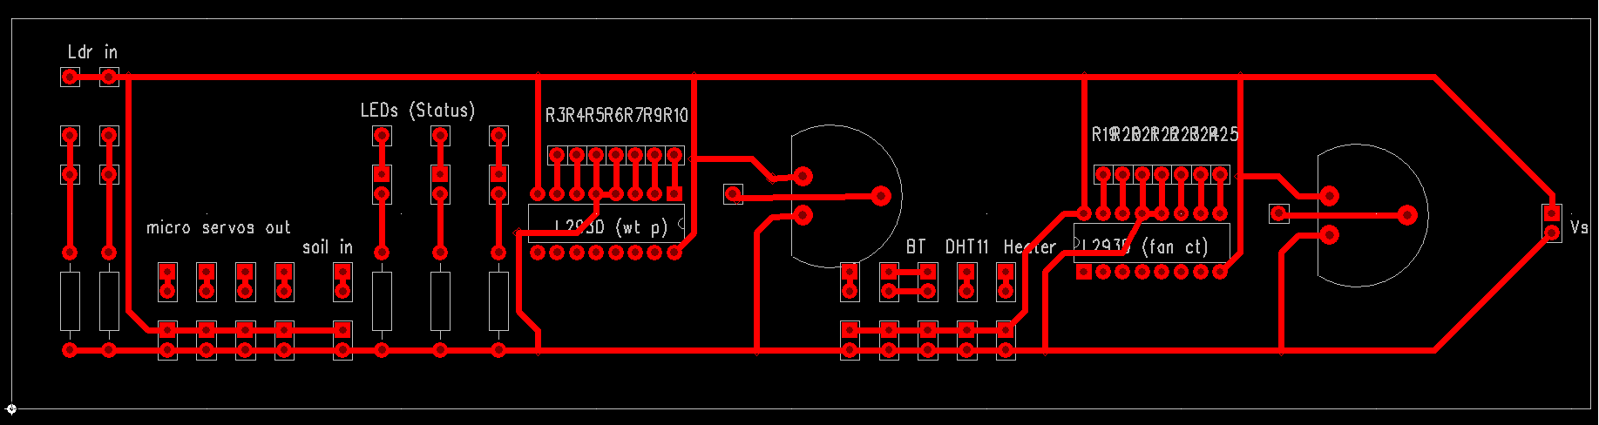

1. Software – 25% (15%)
   1. Layout Design (Android) – 5%

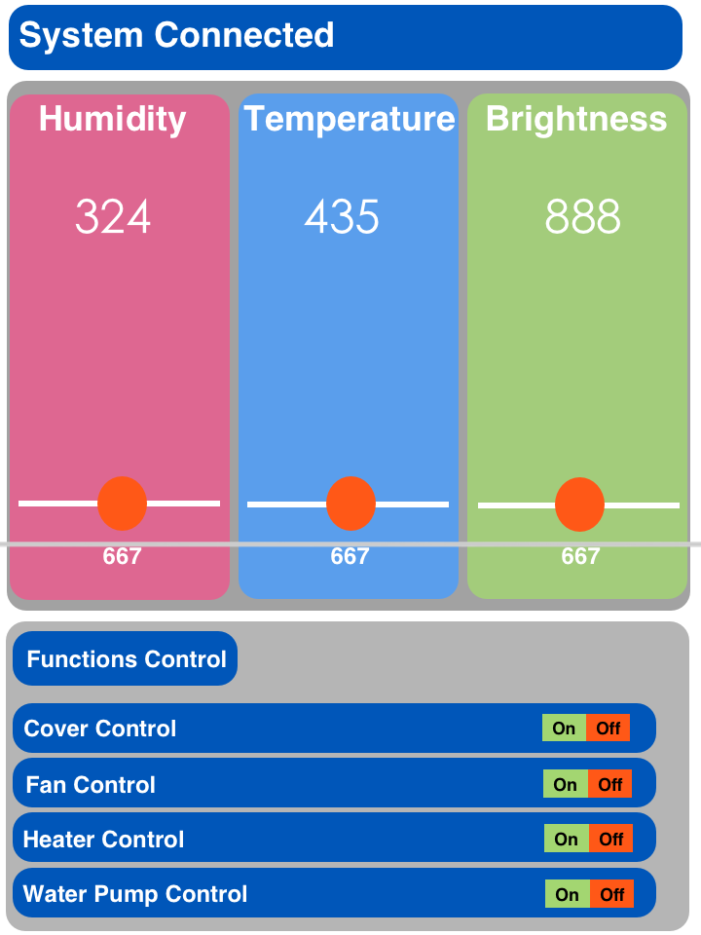­

* 1. Components Testing – 10%

|  |  |
| --- | --- |
| TextView | ✔ |
| ProgressBar | ✔ |
| Switch | ✔ |
| ImageView | ✔ |
| Bluetooth | ✔ |
| Button | ✔ |

What we will do…

1. Software

Functional Integration – 10%

1. Hardware

Soldering – 5%

1. System Integration – 5%
2. Debugging – 10%